BOARD OF DIRECTORS MEETING
INDUSTRIAL DEVELOPMENT AUTHORITY
Of the Town of Front Royal and County of Warren, Virginia
dba as the Economic Development Authority
August 24, 2018, 8:01 a.m.

OFFICIAL - MINUTES

Attendance, Directors: Mark Baker, Bill Biggs, Gray Blanton, Greg Drescher, Bruce Drummond, Ron Llewellyn and Thomas Patteson.

Absent:

Officials, Staff & Others: Jennifer McDonald, Dan Whitten, Hollis Tharpe, Joe Waltz, Roger Bianchini,Josh Gully and Missy Henry.

CALL TO ORDER: Greg Drescher

ADDITIONS/DELETIONS TO AGENDA:
Mr. Drescher advised we will add to the Agenda the following:

Section 2.2-3711.A.1: Discussion, consideration or interviews of perspective candidates for employment, assignment, appointment, promotion, performance, demotion, salaries, disciplining or resignation of specific public officers, appointees or
employees of any public body. I further move that discussion be limited to a part time marketing position.
Also, under Section 2.2-3711.A.8 add to discuss the EDA budget.

APPROVAL OF MINUTES: July 2018

ON A MOTION BY MR. BIGGS (SECOND BY DR.BLANTON) THE BOARD VOTED TO APPROVE THE MINUTES. VOTE: ALL “AYE”; NONE OPPOSED; MOTION CARRIED.

FINANCIALS: July 2018

Will be discussed at Septembers Meeting.

COUNTY ADMINISTRATOR UPDATE: Doug Stanley-absent
Development Review Committee – The Development Review Committee met on August 22, 2018
The Committee discussed projects in the County including:
- The site plan for the new Chapel at Christendom College.
- The site plan for the parking lot expansion/commuter lot beside the existing Exxon in Linden.
- A conditional use permit for a commercial garden center on Loop Road.
- Dominion Power’s proposed security fence upgrades.

The Committee also discussed Town projects including:
- Update on Afton Inn. Conceptual plans have been approved, asbestos removal has been completed, and demolition permits have been approved.
- Update on the Community Development Block Grant regarding a meeting forthcoming with owners of Main Street buildings. Construction should begin in Spring 2019.
The Committee will meet again on September 26, 2018.

Comprehensive Plan Update – The Comprehensive Plan, also referred to as a general plan, master plan or land-use plan, is a document designed to guide the future actions of a community. It presents a vision for the future, with long-range goals and objectives for all activities affecting the local government.
The County has recently contracted with EPRPC through LPDA to conduct a visioning process to kick off the update of the County’s Comprehensive Plan. The Plan was last approved by the Board of Supervisors on July 16, 2013. The County is required to begin the update of the Plan every five years. The update began in July with a citizen survey. The survey addresses various topics such as land use, education, housing, County services, parks and recreation, transportation, taxes, etc. The Plan provides the framework for how the community wishes to develop over the next 15-20 years. The survey was an excellent opportunity for citizens to become involved in the update of the Plan, which is the County’s official guide for future development related decisions.
EPRPC met with two groups that included representatives of the County, Town, School System, EDA, and Chamber on July 20th to get feedback on the progress of the School System. That information, along with our Vision survey, will be used for the Visioning session to be held with the Board in September. The EDA will be asked to send a couple Board members to participate in that session.
Reassessment – Wingate Appraisal has completed approximately 21,666 parcels or 84.6%. Wingate Appraisal is continuing with field work inside the limits of the Town of Front Royal. The plan is to have the initial property visits completed by the end of September. Their next step is to visit, as necessary, all properties where building permits have occurred during the Reassessment in order to update those assessments. The amount of time necessary for this phase will depend on the volume of permits, but they expect this to occur during October. Also during October, Wingate will be running edits and data reports to assure the values are as good and error free as they can be prior to mailing notices of assessment change. Notices should be mailed near the end of October and will show hearing location, dates and times of hearings, the proposed assessment, previous assessments, percentage of change, as well as the levy. The administrative hearings, also known as the assessor’s hearings, should begin at or near the first of November. Wingate expects the hearings and reviews to take most of the month of November with about two weeks of advertised hearing dates. Owners will likely be notified the result of their appeal during December which is when the Reassessment Book is run and delivered to the Clerk of Court and Commissioner of the Revenue along with the recapitulation which will be forwarded to the Department of Taxation.
Delinquent Taxes – On July 24th TACS held a sale of 43 delinquent tax properties. The sale was well attended and the 42 properties brought a total of $186,100. Pond Law Group is scheduled to have a sale of about 30 properties this fall.
Tourism Committee – The Joint Tourism Committee met on August 8th and discussed the objectives of its three subcommittees involving wayfinding signage, marketing/branding, and a local ambassador program. They also discussed the Civil War Trails Program and received an update from the Town regarding its current tourism projects. The Committee will meet again on September 12th.
VDOT/Smart Scale Applications – The VDOT FY 2019 Smart Scale project application project was opened to localities to submit local transportation priorities for evaluation and scoring based on the adopted program criteria. Warren County can submit up to four projects for consideration. Staff has worked with VDOT to identify four projects based on safety, need, community impact, and cost. The four projects which were approved by the Board and sent to VDOT are:

1. Route 55 East Corridor Safety Improvements. Implement safety enhancements to include EP rumble strips, raised pavement markers, guardrail upgrades, signage upgrades, electronic speed feedback signage, roadside lighting, and fixed object hazard removal, along the 3.0 mile corridor between the Town of Front Royal Corporate Limits and Route 79 at Linden.
2. I-66 Exit 6 Westbound On Ramp Extension. Extend the existing Route 340/522 southbound on ramp to I-66 westbound to the Crooked Run Boulevard intersection to address capacity, weaving, and safety issues.
3. Route 340/522 North. Install roadside lighting along a 1.6 mile long segment of the corridor from the Town of Front Royal Corporate Limits to the Diamond Ridge Drive intersection to address nighttime visibility and safety issues for motorists and pedestrians. The project would also include lighting of the I-66 Exit 6 interchange.
4. Route 658/Rockland Road. Eliminate an existing double track at-grade Norfolk Southern Railway crossing adjacent to the Virginia Inland Port by constructing a new bridge overpass. Rockland Rd. would be slightly re-aligned, and the intersection of Route705 relocated with turn lanes provided into the adjacent Rockland Park. The project would address numerous train blockages, motorist delays, and life/safety accessibility issues into this section of Warren County.
In addition to the four projects, the Northern Shenandoah Valley Regional Commission has submitted two projects; improve the Route 79/Route 55 Intersection in Linden and expand the Linden Park-n-Ride.

Project Updates
Ressie Jeffries Elementary School – Roof/Addition/Parking Lot Project/ Playground Project – WCPS held a formal ribbon cutting for all of the improvements on August 7th.
Health and Human Services Complex – The Board of Supervisors, at its meeting on April 3rd, awarded a contract to Juniper Construction for improvements to portions of the building to accommodate the Registrar’s Office and the Brighter Futures alternative school program. The contractor began work the week of June 4th. The current schedule has the school portion complete by October 1st and the Registrar by November 1st.
VDOT/Marlow-Silek Revenue Sharing Project – The project is substantially completed. We are waiting on final acceptance by VDOT and DEQ and final invoicing from the contractor. Thanks to the EDA for spearheading this project. Because of your efforts, we were able to provide access for the Royal Farms site and an additional 2-4 commercial pad sites at North River Square.
VDOT/Morgan Ford Bridge – The bridge and roadway opened to traffic on January 22nd and was substantially completed by June 1, 2018 per the contract. The bridge approaches were damaged during the recent flooding, and temporary repairs have been completed. Additional repairs will be made prior to the scheduling of a ribbon cutting ceremony now planned for late August.
Commercial Projects – Work continues on the following projects:
    - Marriott/TownePlace Suites – Winter 2018 Completion
County is currently reviewing site plans for:
    - Taco Bell – Riverton Commons
    - Burger King – Linden
    - Valvoline – Riverton Commons

Project | Ad/Bid Date | Cost | Estimated Completion Date | Status
FRWC Airport Obstruction Removal | Summer 2016 | $804,000 | Summer 2018 | Substantially Complete _ Punch List
Ressie Jeffries Renovations | Fall 2016 | $5,405,885 | Spring 2018 | Completed
Rockland Park Athletic Fields | N/A | $300,000-$400,000 | Summer 2018 | Under Construction
Thompson Kiss-and-Ride – Bus Shelter | N/A | $15-20,000 | Summer 2018 | August /September Construction
Rockland Park Bathhouse Renovation | N/A | $75,000-$100,000 | Fall 2018 | Under Design
WCSO/WCFR – Radio System Upgrade | N/A | $1,509,022 | Summer 2018 | Installation

DPS

TOWN MANAGER UPDATE: Joe Waltz
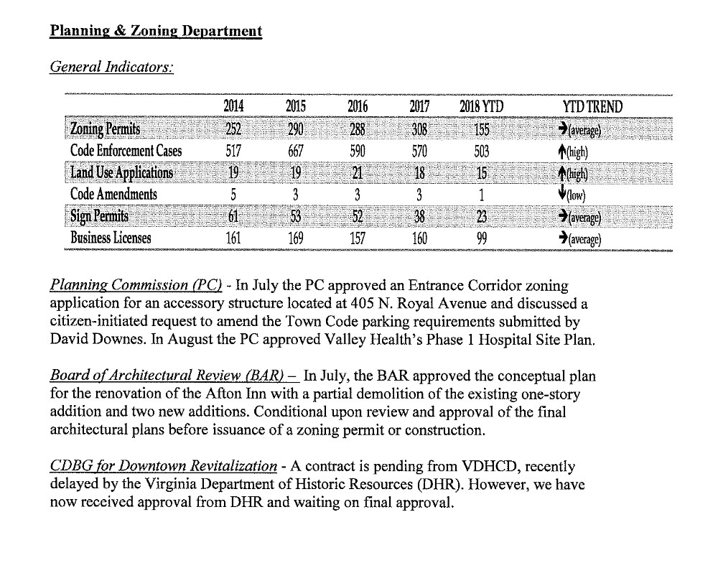

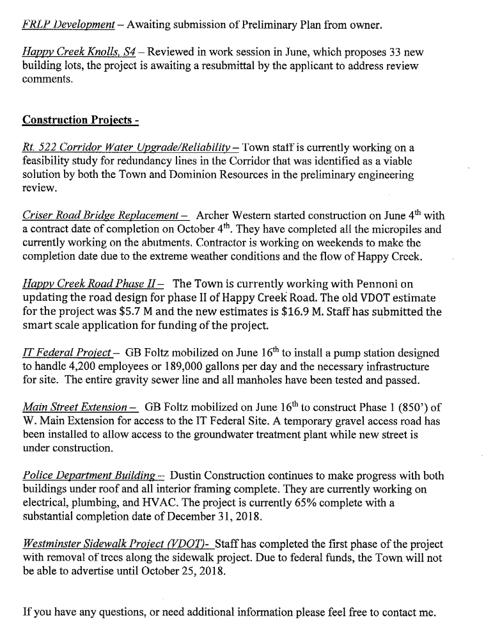

Mr. Blanton asked when the West Main Extension is expected to be completed. Mr. Waltz advised we did submit in the Smart Scale for that. Once we get ITFederal up and running, we will have a more up to date time frame.

Mr. Waltz advised Mr. Llewellyn that all drains are clear in the 6th Street/Commerce Avenue area that was previously discussed due to flooding. The Town Engineer is looking at these issues and it will be put on the CIP.

Chamber of Commerce: Niki Cales-absent

EXECUTIVE DIRECTORS REPORT: Jennifer McDonald
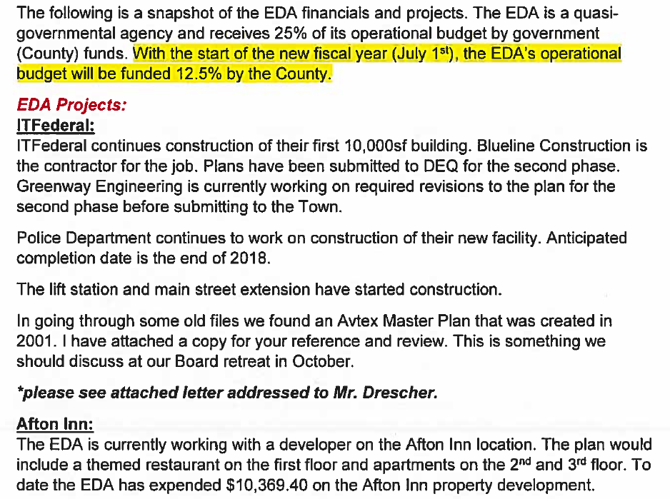

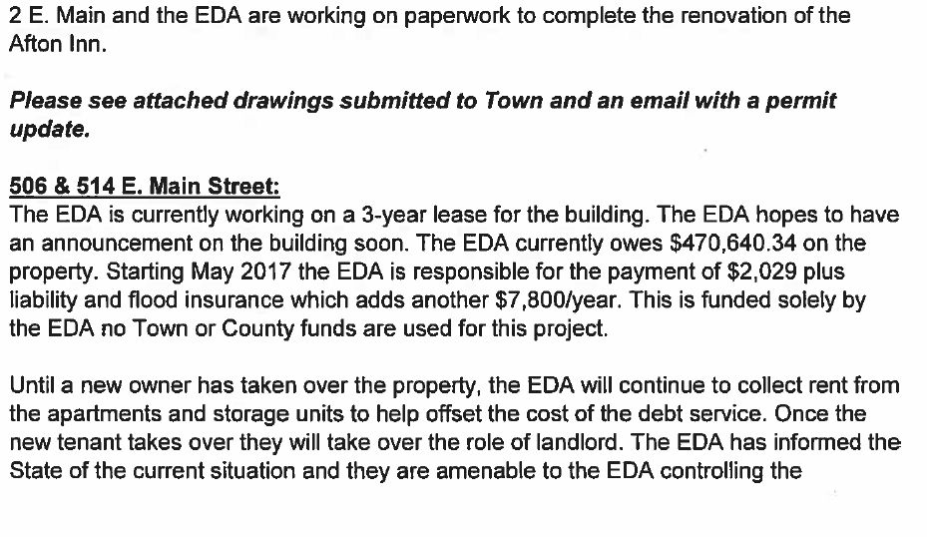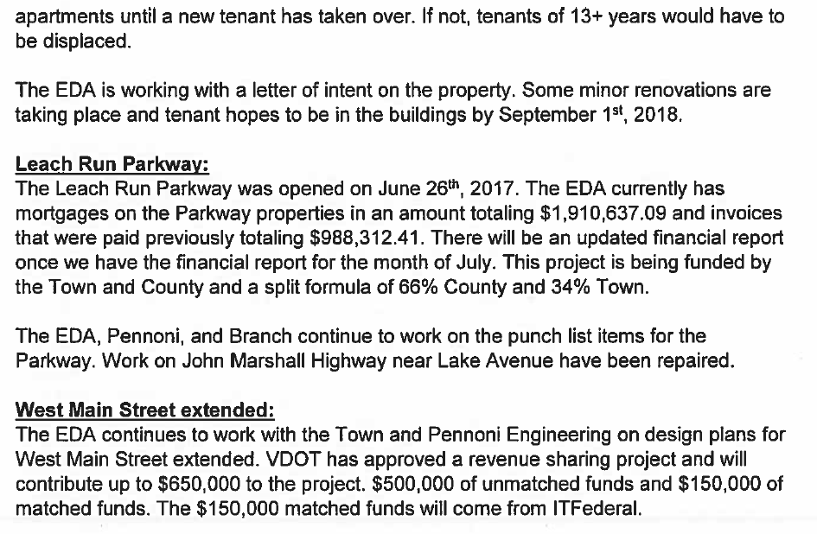
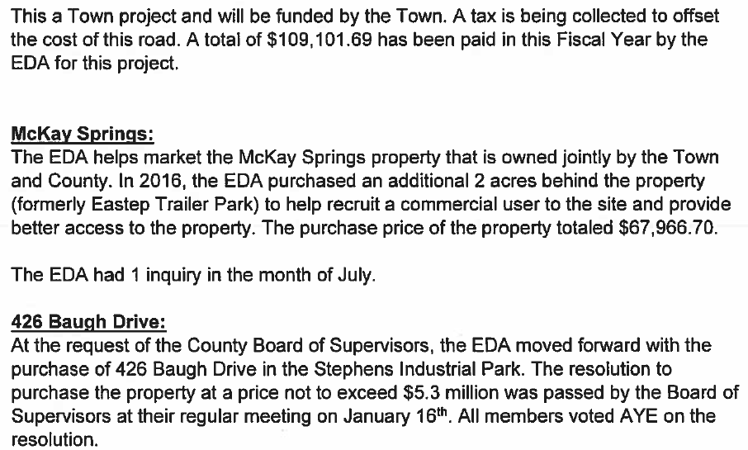

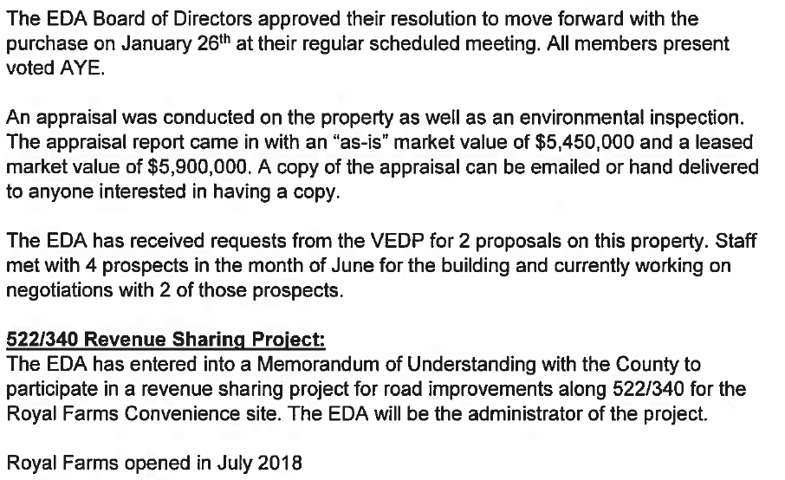

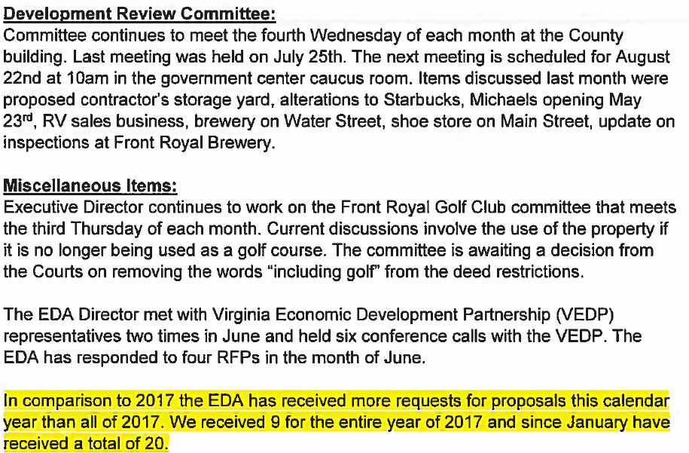

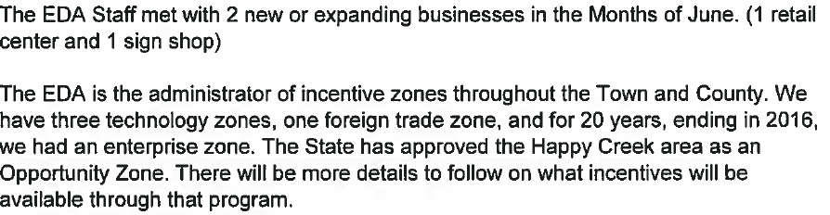

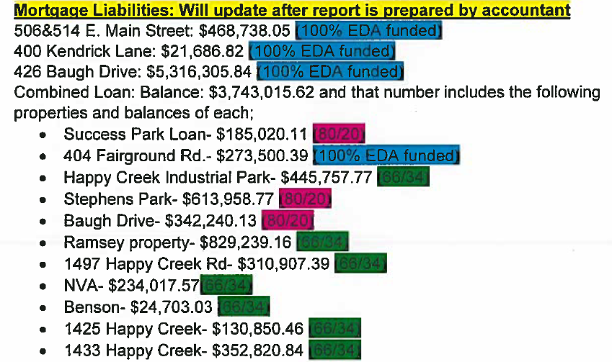

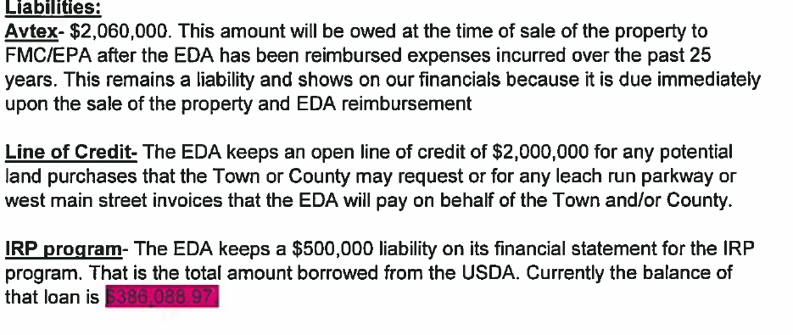

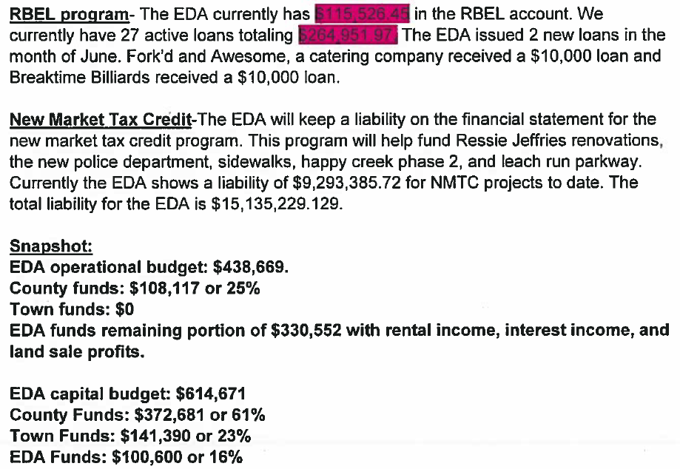

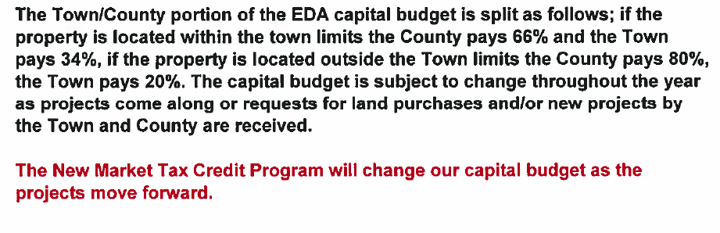
Dr. Patteson inquired about Chic Filet. Ms. McDonald advised they are still looking for a location.

Ms. McDonald stated there is a letter from Mr. Tom Ross included in this months packet. He is congratulating the EDA on its success with the Avtex Superfund and the redevelopment.

STAFF COMMENTS:

DIRECTOR COMMENTS:
Mr. Drummond asked if the ITFederal building being built is ten thousand square ft. Ms. McDonald advised its actually 10,001 square ft.

(8:18 a.m.)

MOTION TO GO INTO CLOSED MEETING

I, Gray Blanton, move that the Board of the EDA vote to go into Closed Meeting under the provisions of Section 2.2-3711 of the Virginia Freedom of Information Act for the following purpose(s):
Section 2.2-3711.A.5: Discussion concerning a prospective business or industry or expansion of an existing business or industry where no previous announcement has been made of the business’s or industry’s interest in locating or expanding its facilities in the community. Such business to be located on the Avtex site, Stephens Industrial Park, Downtown Front Royal specifically Main Street and the Happy Creek Technology Park.
Section 2.2-3711.A.8: Consultation with legal counsel employed or retained by a public body regarding specific legal matters requiring the provision of legal advice by such counsel. I further move that discussion be limited to the discussion of EDA Loan Programs and EDA budget.
Section 2.2-3711.A.1: Discussion, consideration or interviews of perspective candidates for employment, assignment, appointment, promotion, performance, demotion, salaries, disciplining or resignation of specific public officers, appointees or
employees of any public body. I further move that discussion be limited to a part time marketing position.

ROLL CALL VOTE: BAKER,’AYE’; BIGGS,”AYE”; BLANTON, ‘AYE’; DRESCHER,”AYE”; DRUMMOND, “AYE”; LLEWELLYN, “AYE” AND PATTESON, “AYE”.

MOTION COMING OUT OF CLOSED MEETING
On a Motion by Gray Blanton, seconded by Dr. Patteson the Board certifies to the best of each member’s knowledge that only public business matters lawfully exempted from open meeting requirements under this chapter and only such public business matters as were identified in the motion by which the closed meeting was convened were heard, discussed or considered in the meeting by the public body.

ROLL CALL VOTE: BAKER, ‘AYE’; BIGGS, “AYE”; BLANTON, “AYE”, DRESCHER,”AYE”; DRUMMOND, “AYE”, LLEWELLYN, ‘AYE’ AND PATTESON, “AYE”.

(9:15 a.m.)

New Business:
Mr. Greg Drescher read the following statement:

Effective at the end of the August 24, 2018 EDA Board of Director’s Meeting I will be stepping down as chair. I certainly hope to continue to be an active and contributing member of the Board of Directors. Our board has gone through some changes in the past couple of years. The illness and passing of our friends Patty and Jim and as another board member moved from the community, it appeared to be my turn to take on the role of chair.

From the onset I agreed to do this on a short term basis. As all of you know I do have a “real” job that does and should take my primary attention. While I can say with complete certainty neither my role as Superintendent of Warren County Public Schools nor my role as EDA Board Chair suffered in the least. I will say there were times it has taken some juggling. All busy people prioritize and put in the time that is necessary to get the job done.

At this time our newer board members have had a chance to get their sea legs, and I believe our board is very strong and will be in good hands with the next leadership that will be put in place. This will happen at our next regularly scheduled board meeting. It is a pleasure working with this board and alongside of Jennifer and Missy. To a person the EDA has one focus, helping our community become a stronger and more vibrant place to live, work and play.

Mr. Biggs stated and others agreed that Mr. Drescher has done a fine job as Chairman of the EDA Board.

MOTION TO ADJOURN: MOTION WAS MADE BY MR. DRUMMOND WITH A SECOND BY DR. BIGGS TO ADJOURN.

(9:28 a.m.)

The next regular meeting of the EDA Board of Directors is scheduled for
Friday, September 28, 2018, 8:00 AM at the EDA Conference Room.

Respectfully submitted by:

Michelle L. Henry
Administrative Assistant

